* Lab 9: Developing a comprehensive microservices example
* Create a new Spring Boot project and call it chapter2.bootcustomer, the same way as earlier. Select the options as in the following screenshot in the starter module selection screen:
* 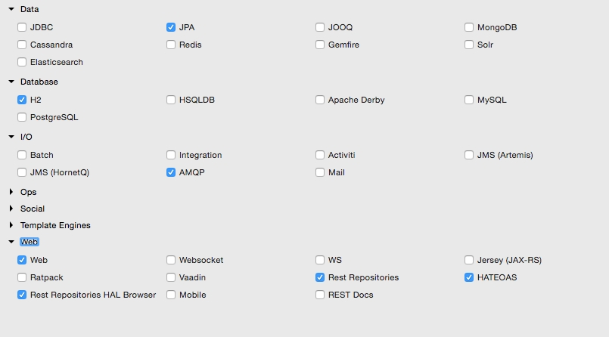
* This will create a web project with JPA, the REST repository, and H2 as a database. H2 is a tiny in-memory embedded database with which it is easy to demonstrate database features. In the real world, it is recommended to use an appropriate enterprise-grade database. This example uses JPA to define persistence entities and the REST repository to expose REST-based repository services.
* The project structure will be similar to the following screenshot:
* 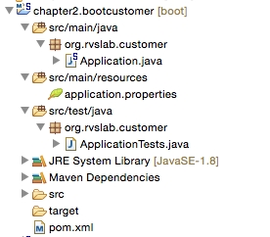
* Start building the application by adding an Entity class named Customer. For simplicity, there are only three fields added to the Customer Entity class: the autogenerated id field, name, and email. Take a look at the following code:
* @Entity  
  class Customer {  
   @Id  
   @GeneratedValue(strategy = GenerationType.AUTO)  
   private Long id;  
   private String name;  
   private String email;
* Add a repository class to handle the persistence handling of Customer. CustomerRepository extends the standard JPA repository. This means that all CRUD methods and default finder methods are automatically implemented by the Spring Data JPA repository, as follows:
* @RepositoryRestResource  
  interface CustomerRespository extends JpaRepository <Customer,Long>{  
   Optional<Customer> findByName(@Param("name") String name);  
  }
* In this example, we added a new method to the repository class, findByName, which essentially searches the customer based on the customer name and returns a Customer object if there is a matching name.
* The @RepositoryRestResource annotation enables the repository access through RESTful services. This will also enable HATEOAS and HAL by default. As for CRUD methods there is no additional business logic required, we will leave it as it is without controller or component classes. Using HATEOAS will help us navigate through Customer Repository methods effortlessly.
* Note that there is no configuration added anywhere to point to any database. As H2 libraries are in the class path, all the configuration is done by default by Spring Boot based on the H2 autoconfiguration.
* Update the Application.java file by adding CommandLineRunner to initialize the repository with some customer records, as follows:
* @SpringBootApplication  
  public class Application {  
   public static void main(String[] args) {  
   SpringApplication.run(Application.class, args);  
   }  
    
   @Bean  
   CommandLineRunner init(CustomerRespository repo) {  
   return (evt) -> {  
   repo.save(new Customer("Adam","adam@boot.com"));  
   repo.save(new Customer("John","john@boot.com"));  
   repo.save(new Customer("Smith","smith@boot.com"));  
   repo.save(new Customer("Edgar","edgar@boot.com"));  
   repo.save(new Customer("Martin","martin@boot.com"));  
   repo.save(new Customer("Tom","tom@boot.com"));  
   repo.save(new Customer("Sean","sean@boot.com"));  
   };  
   }  
  }
* CommandLineRunner, defined as a bean, indicates that it should run when it is contained in SpringApplication. This will insert six sample customer records into the database at startup.
* At this point, run the application as Spring Boot App. Open the HAL browser and point the browser to http://localhost:8080.
* In the **Explorer** section, point to http://localhost:8080/customers and click on **Go**. This will list all the customers in the **Response Body** section of the HAL browser.
* In the **Explorer** section, enter http://localhost:8080/customers?size=2&page=1&sort=name and click on **Go**. This will automatically execute paging and sorting on the repository and return the result.
* As the page size is set to 2 and the first page is requested, it will come back with two records in a sorted order.
* Review the **Links** section. As shown in the following screenshot, it will facilitate navigating **first**, **next**, **prev**, and **last**. These are done using the HATEOAS links automatically generated by the repository browser:
* 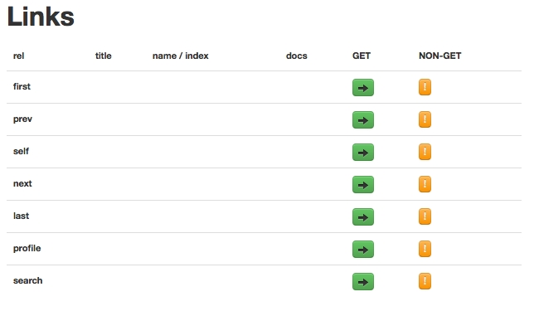
* Also, one can explore the details of a customer by selecting the appropriate link, such as http://localhost:8080/customers/2.
* As the next step, add a controller class, CustomerController, to handle service endpoints. There is only one endpoint in this class, /register, which is used to register a customer. If successful, it returns the Customer object as the response, as follows:
* @RestController  
  class CustomerController{  
     
   @Autowired  
   CustomerRegistrar customerRegistrar;  
     
   @RequestMapping( path="/register", method = RequestMethod.POST)  
   Customer register(@RequestBody Customer customer){  
   return customerRegistrar.register(customer);  
   }  
  }
* A CustomerRegistrar component is added to handle the business logic. In this case, there is only minimal business logic added to the component. In this component class, while registering a customer, we will just check whether the customer name already exists in the database or not. If it does not exist, then we will insert a new record, and otherwise, we will send an error message back, as follows:
* @Component   
  class CustomerRegistrar {  
     
   CustomerRespository customerRespository;  
     
   @Autowired  
   CustomerRegistrar(CustomerRespository customerRespository){  
   this.customerRespository = customerRespository;  
   }  
     
   Customer register(Customer customer){  
   Optional<Customer> existingCustomer = customerRespository.findByName(customer.getName());  
   if (existingCustomer.isPresent()){  
   throw new RuntimeException("is already exists");  
   } else {  
   customerRespository.save(customer);   
   }  
   return customer;  
   }  
  }
* Restart the Boot application and test using the HAL browser via the URL http://localhost:8080.
* Point the **Explorer** field to http://localhost:8080/customers. Review the results in the **Links** section:
* 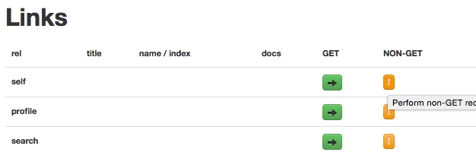
* Click on the **NON-GET** option against **self**. This will open a form to create a new customer:
* 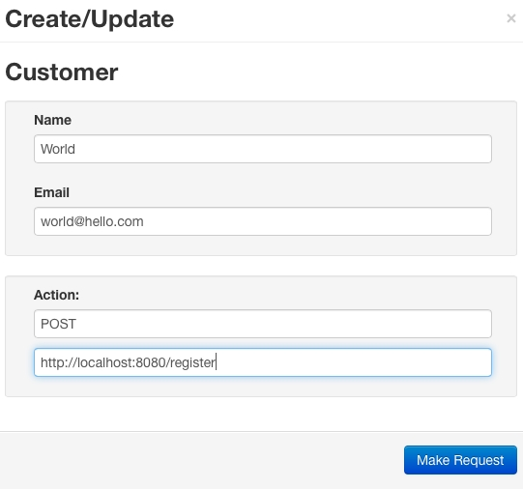
* Fill the form and change the **Action** as shown in the diagram. Click on the **Make Request** button. This will call the register service and register the customer. Try giving a duplicate name to test the negative case.
* Let's complete the last part in the example by integrating the Customer Notification service to notify the customer. When registration is successful, send an e-mail to the customer by asynchronously calling the Customer Notification microservice.
* First update CustomerRegistrar to call the second service. This is done through messaging. In this case, we injected a Sender component to send a notification to the customer by passing the customer's e-mail address to the sender, as follows:
* @Component   
  @Lazy  
  class CustomerRegistrar {  
     
   CustomerRespository customerRespository;  
   Sender sender;  
     
   @Autowired  
   CustomerRegistrar(CustomerRespository customerRespository, Sender sender){  
   this.customerRespository = customerRespository;  
   this.sender = sender;  
   }  
     
   Customer register(Customer customer){  
   Optional<Customer> existingCustomer = customerRespository.findByName(customer.getName());  
   if (existingCustomer.isPresent()){  
   throw new RuntimeException("is already exists");  
   } else {  
   customerRespository.save(customer);   
   sender.send(customer.getEmail());  
   }   
   return customer;  
   }  
  }
* The sender component will be based on RabbitMQ and AMQP. In this example, RabbitMessagingTemplate is used as explored in the last messaging example; take a look at the following:
* @Component   
  @Lazy  
  class Sender {  
     
   @Autowired  
   RabbitMessagingTemplate template;  
    
   @Bean  
   Queue queue() {  
   return new Queue("CustomerQ", false);  
   }  
     
   public void send(String message){  
   template.convertAndSend("CustomerQ", message);  
   }  
  }
* The @Lazy annotation is a useful one and it helps to increase the boot startup time. These beans will be initialized only when the need arises.
* We will also update the application.property file to include Rabbit MQ-related properties, as follows:
* spring.rabbitmq.host=localhost  
  spring.rabbitmq.port=5672  
  spring.rabbitmq.username=guest  
  spring.rabbitmq.password=guest
* We are ready to send the message. To consume the message and send e-mails, we will create a notification service. For this, let's create another Spring Boot service, chapter2.bootcustomernotification. Make sure that the **AMQP** and **Mail** starter libraries are selected when creating the Spring Boot service. Both **AMQP** and **Mail** are under **I/O**.
* The package structure of the chapter2.bootcustomernotification project is as shown here:
* 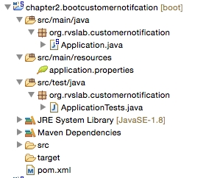
* Add a Receiver class. The Receiver class waits for a message on customer. This will receive a message sent by the Customer Profile service. On the arrival of a message, it sends an e-mail, as follows:
* @Component  
  class Receiver {   
   @Autowired  
   Mailer mailer;  
     
   @Bean  
   Queue queue() {  
   return new Queue("CustomerQ", false);  
   }  
    
   @RabbitListener(queues = "CustomerQ")  
   public void processMessage(String email) {  
   System.out.println(email);  
   mailer.sendMail(email);  
   }  
  }
* Add another component to send an e-mail to the customer. We will use JavaMailSender to send an e-mail via the following code:
* @Component   
  class Mailer {  
   @Autowired  
   private JavaMailSender javaMailService;  
   public void sendMail(String email){  
   SimpleMailMessage mailMessage=new SimpleMailMessage();  
   mailMessage.setTo(email);  
   mailMessage.setSubject("Registration");  
   mailMessage.setText("Successfully Registered");  
   javaMailService.send(mailMessage);  
   }  
  }
* Behind the scenes, Spring Boot automatically configures all the parameters required by JavaMailSender.
* To test SMTP, a test setup for SMTP is required to ensure that the mails are going out. In this example, FakeSMTP will be used. You can download FakeSMTP from <http://nilhcem.github.io/FakeSMTP>.
* Once you download fakeSMTP-2.0.jar, run the SMTP server by executing the following command:
* **$ java -jar fakeSMTP-2.0.jar**
* This will open a GUI to monitor e-mail messages. Click on the **Start Server** button next to the listening port textbox.
* Update application.properties with the following configuration parameters to connect to RabbitMQ as well as to the mail server:
* spring.rabbitmq.host=localhost  
  spring.rabbitmq.port=5672  
  spring.rabbitmq.username=guest  
  spring.rabbitmq.password=guest  
    
  spring.mail.host=localhost  
  spring.mail.port=2525
* We are ready to test our microservices end to end. Start both the Spring Boot apps. Open the browser and repeat the customer creation steps through the HAL browser. In this case, immediately after submitting the request, we will be able to see the e-mail in the SMTP GUI.
* Internally, the Customer Profile service asynchronously calls the Customer Notification service, which, in turn, sends the e-mail message to the SMTP server:
* 